“L4 Bursom Burner/Heat Exchanger” U.R.S.

Project: “Replacement of L4 Burner/Heat Exchanger to feed a PC36 with APC+ ”

USER REQUIREMENT SPECIFICATION

Dated: 28/02/14
Version: 3.0

Approved by | Signature | Date
Technical Services | Keith Butler | 25/10/13
Site Leader | Simon Devaney
Site Engineering Manager | Liz Butler | 25/10/13
Site Project manager | Dave Pickup | 25/10/13
Site Sustainability Manager | Liz Penfold
Site Safety Manager | James Whieldon
Site C.S.S. | Simon Ingle
Site Operations Manager | Phil Tetley | 25/10/13

REVISION HISTORY

Date | Version | Originator | Sections Changed
14/10/2013 | 1.0 | Dave Pickup | *First Draft*
21/10/2013 | 1.1 | Dave Pickup | Update with scope and KPI’s
25/10/2013 | 2.0 | Dave Pickup | Scope and KPI Amendments from site and ETS
28/10/2013 | 2.1 | Dave Pickup | C.S.S. wording amendments to 6.4.2, 6.8 and 6.11. Inclusion of P&ID and HAZOP in 2.3 and 4.2
07/11/2013 | 2.2 | Dave Pickup | Update to Section 7.1.8 waste KPI
11/12/2013 | 2.3 | Dave Pickup | Timeline and KPI amendments to reflect installation/ commissioning
30/01/2014 | 2.4 | Dave Pickup | Correction to font size in KPI table 7.2.1 and time plan updated.
28/02/2014 | 3.0 | Dave Pickup | 2.3.1 Safety Requirements. PLC requirements.

This document is confidential and proprietary. No information shall be disclosed, copied, or used for any purpose other than for which it is specifically furnished without the prior written consent of PepsiCo
Table of Contents
1.0 Project Information 5
1.1 Key project and Delivery Information 5
1.2 Confidentiality 5
1.3 Language 6
1.4 Definitions 6
1.5 Reference Documents 6
2. Scope of Supply 7
2.1 Introduction 7
2.2 Project Overview 7
2.3 Extent of Supply 7
2.3.1 Specific safety requirements 8
2.4 Work to be completed by others – e.g. other contractors. 8
3. Products and Plant Overview 9
3.1 Required Setup 9
3.2 System General Description 9
3.4 Equipment Details 9
3.4.1 Equipment Details 1 9
3.4.2 Equipment Details 2 10
3.5 Products 10
4. Commercial Details 10
4.1 Cost Breakdown 10
4.2 Timelines 10
4.3 Post Project Support 11
4.4 Training 11
4.5 Documentation 11
4.6 Project Management 13
4.7 Insurance 13
4.8 Contract 13
4.9 Support 13
5. Design 14
5.1 Construction Standards 14
5.2 Maintenance 14
5.3 Installation 15
5.3.1 Specific Instructions 16
5.4 CE approvals 16
5.6 Lean Design & Visual Management 16
5.6.1 Visual management 16
6. Control System Hardware 17
6.1 Preferred Equipment 17
6.2 Proposed Network 17
6.3 Programming structure. 17
6.4 Operator Interface 18
6.4.1 Industrial PC Requirements 18
6.4.2 H.M.I / PC Operations 18
6.4.3 Alarms 19
6.5 Control Panels 20
6.6 Field Equipment 21
6.7 Instrumentation 21
6.8 Recipes / Presets 21
6.9 Data Handling 21
6.10 Emergency Stops / Controlled stop 22
6.11 System or Power Failure 22
7. Performance 23
7.1 Generic Key Performance Indicators 23
7.1.1 Operating Environment 23
7.1.2 System Efficiency 23
7.1.3 Downtime 23
7.1.4 Cost of Ownership 24
7.1.5 Metal to Metal Contact 24
7.1.6 Product Spillage 24
7.1.7 Hold-up Points 24
7.1.8 Waste 24
7.2 Project Specific Key Performance Indicators 25
7.2.1 Thermal Transfer Efficiency 25
7.2.2 Oil Temperature Set Point Response. 25
7.2.3 System Reliability 26
7.2.4 Capacity/Operating Environment 26
7.2.5 Oil Turnover rates 26
7.2.6 Burner Turn-Down Rate 26
7.2.7 Integrity of Insulation/Refractory 26
7.2.8 Oil Film Temperatures 27
7.2.9 Surface Temperatures 27
7.2.10 Destruction of Fryer Stack Contaminants 27
7.2.11 Heat Exchanger Drainage Time and residual volume 28
7.2.12 Noise Levels 28
7.2.13 Corrosion 28
7.3 Guarantees 28
7.4 Environment 28
8. Site Impact 30
8.1 Buildings / Access to site 30
8.2 Utilities 30
8.4 Plant Environment 30
8.5 Noise Control 30
9. Acceptances and Handover 31
9.1 Acceptance Testing 31
Appendix 1 – Efficiency calculation & reporting 32
Heat exchanger efficiency trending 32
Efficiency Logging 34

Project Information

1.1 Key project and Delivery Information

Correspondence:  All correspondence regarding the Burner project should be routed via those detailed in this section. | Engineering Manager | Liz Butler | liz.butler@pepsico.com  +44(0)1162342000
 | Site Project Manager | Dave Pickup | dave.pickup@pepsico.com  +44(0)1162345476
 | ETS Support | Keith Butler | keith.butler@pepsico.com
Site Address:  Delivery should be through a pre agreed delivery schedule to the following address: | Bursom Factory  11 Bursom Road  Beaumont Leys  Leicester  LE4 1BS
Invoice & paperwork Address: | Invoice  1600 Arlington Business Park, Theale, Reading, RG7 4SA  Paperwork Address:  11 Bursom Road, Beaumont Leys, Leicester, LE4 1BS
Site Information: | Site Temp / Humidity:  The environmental specification for the factory area is:  External Average Temp 2 – 20ºC  External Average Humidity 74 – 89%  Seasonal spikes do occur either way for both. |  |  | Site Power Supply:  415V 3 Phase

1.2 Confidentiality
This project should be considered as confidential and not discussed with a third party unless written permission is given by the Project Manager.

1.3 Language
All quotations in English, documentation and software should be in English
All site installation works, operation manuals, training documentation and operator interface should be provided in English
Operator interface shall be in English

1.4 Definitions
- KPI - Key Performance Indicator
- PE – PepsiCo Europe

1.5 Reference Documents
The following documents apply and must be read in conjunction with this URS:
- Electrical Engineering Specifications March 2012
- Mechanical Engineering Specifications 2007
- Management of Works 2012
- Building Services Utilities Specification 2008
- PepsiCo Civils Spec -July 07
- MESS standards EHS-50

2. Scope of Supply

2.1 Introduction
The Purpose of this document is not to define the technical specifications of any equipment being considered but to outline the end user requirements for the Replacement of L4 Heater/Burner to feed a PC36 APC+ fryer.

This User Requirements Specification (URS) describes the mechanical, electrical and control system for the operation of the equipment.

The mechanical, electrical, civil and services scopes of work are to be in line with the PepsiCo Europe specifications unless notified in this document

2.2 Project Overview
The project is to install a replacement burner and heat exchanger in the current location of Line 4’s existing unit to feed an existing PC36 Fryer. This document describes the expected technical requirements and KPI’s for the performance of this unit.

2.3 Extent of Supply
The following is expected:
- Complete a sign off drawing for all parties to agree final installation and layout design before manufacture. This should include concepts such as Lean by Design.
- Prepare an FDS, HDS, SDS and P&ID for review.
- Run a HAZOP from P&ID with site representatives.
- Provide and maintain a project schedule for the following works:
- Roof and ceiling works (removal and refitting) associated with making access for equipment egress/ingress.
- Decommission and removal of existing Heater/Burner and associated equipment and panels.
- Installation of the new heater with high efficiency upgrades, including Combustion Management, Hi tech surface coatings, etc.
- Installation of new Heater/Burner Control Panels including Mess Risk assessments, field wiring and existing PLC/Scada/Wonderware integration by a PepsiCo approved System integrator.
- Quotes must include connection off all Heater Services – electricity, gas, Pollution duct work, Noise reduction, stack to atmosphere etc.
- Heater/Burner Transport to site.
- Crane work associated with removal and installation of heaters.
- Wet and Dry commissioning of New Heater/Burner including Mechanical and Electrical Training for engineers and Heater and Burner Panel/OIT operator training.
- It is expected that the Heater/Burner will incorporate an access Platform to fans and tube bundle area.
- The burner needs to be a duel fuel unit for natural gas and diesel and needs to be commissioned on both.
- The feed gas supply must contain a monitored gas flow meter.
- As part of the installation the central stack will need to be removed and line 5 stack made good.
- Making good any flooring and exposed drains.
- Waste streams and removal are to be properly managed.
- CDM, Site safety and Project Management is expected to be undertaken by a nominated Manager from the tendering company. This individual shall be the responsible person for the duration of the works, and is expected to oversee site coordination and supervision. They will also be expected to attend Site meetings to assess project management needs and progress. See section 4.6
- Provide good operator access and maintenance access to all equipment (Lean by Design).
- Provide all parts required to ensure the system is running to agreed performance
- Provide all technical documentation
- Provide technical support and post project support

2.3.1 Specific safety requirements
- It is deemed necessary that a Guard Logix or equivalent should be used for the control of the burner and its ancillaries due to parts of the code being intrinsically linked to safety requirements of the system.
- There is a requirement for control of the CIP leg. This should include a trapped key system, with a flow switch and twin automatic valves that are policed.

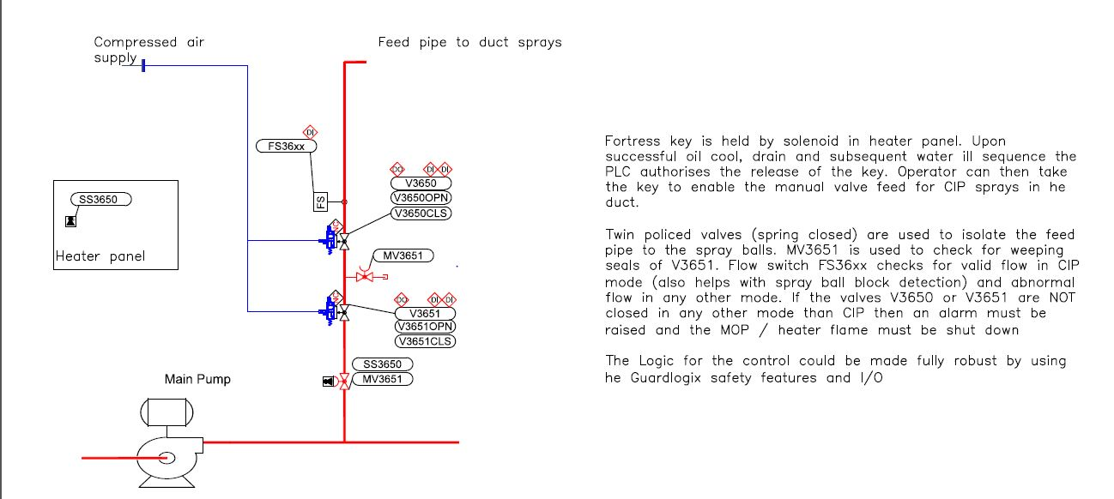

2.4 Work to be completed by others – e.g. other contractors.
It is expected that all sub-contract works are to fall under the project management banner of the successful tender.

3. Products and Plant Overview

3.1 Required Setup
The initial purpose for the installation is to feed L4 fryer providing a throughput of 2100Kg/hr of finished product or a maximum delta T of 25.6ºC. (please see Full KPI specifications later in this document). There must also be provision for the installation to be transposed to feed line 5 fryer in the future.

3.2 System General Description
A new high efficiency Burner/Heat Exchanger which must be capable of providing a throughput of 2100Kg/hr of finished product or a maximum delta T of 25.6ºC. See Specific KPI’s - Section 7.2

It must fit into the current available foot print, use the active services supplies and fit to the existing frying equipment, whilst being fully integrated into the factory control systems.

Economiser capability is to be quoted as an option, to provide hot water for various uses within the factory. All instrumentation feed back to PLC and updated on OIT.

3.4 Equipment Details

3.4.1 Equipment Details 1
A High Efficiency Heat Exchanger system is required for line 4 PC36 APC+ controlled fryer. The fuel for the burner will be natural gas or diesel.
The Burner and Heat Exchanger Supplier shall provide all associated process equipment and quote for the system as a complete, installed package.
The System Supplier will provide the necessary process and pipework design details, and complete P&ID’s and arrange for Mechanical Installation by a reputable installer. Scope will include; Controls Functional Design Specification and Hardware Design Specification.
The intended scope for the Burner and Heat Exchanger System is for a turnkey system.
The line SCADA system shall be updated (by a PepsiCo approved System Integrator appointed by the supplier) to add a mimic of the Burner/heat Exchanger and the Efficiency reporting requirements as detailed in Appendix 1. The Supplier shall either provide a local Operator Interface at the Heat Exchanger control panel for manual and maintenance operation or shall upgrade the line SCADA system to provide this functionality.
The Supplier shall re-tune any Oil Temperature Control loops affected by the Heat Exchanger replacement using a PepsiCo approved System Integrator appointed by the supplier.
The Burner & Heat Exchanger shall interface to the existing Fire Suppression System on the fryer, such that if the Fire Suppression water mist is released, the Burner and Heat Exchanger shut down and leave all dampers associated with the fryer closed to maximise the effectiveness of the water mist fire suppression. (Including the possibility of Fire Suppression release during a power failure)

3.4.2 Equipment Details 2
The System Supplier should Project Manage, Design, Test, Deliver, and Commission the Burner and Heat Exchanger System in collaboration with the Pepsico Engineering representatives.
The System Supplier should provide a project schedule to show how the proposal meets the Project Management Team’s schedule at the start and during the project life cycle.

3.5 Products
PC:
Flats
Crinkles
Deep Ridged

4. Commercial Details

4.1 Cost Breakdown
- A fixed price itemised quotation should be submitted.
- A description of the interfaces with the line control systems required to meet the functionality should be included.

4.2 Timelines
A first level detail timeline Gantt chart (MS Project file) will be required with the tender. This should reflect all aspects of the project, before, during and after installation.

Key project dates –
URS Issued | 25/10/2013
Tender Completion and quotation to be returned | 08/11/2013
Tender and Design Presentation | N/A
Confirmation and Order  Placement | 31/01/14
Design Freeze | 28/02/14
System FDS, HAZOP, HDS, and P&ID | 18/03/13
SDS | TBC
Pre Delivery Inspection | 02/06/14
Old Burner Removal | 09/06/14
Deliver to Site | 20/06/14
Technical/Operator Training | TBC
Installation Complete | 11/07/14
Commissioning Complete | 18/07/14
Service to Sales | 18/07/14

4.3 Post Project Support
Support should be available during normal office hours; site attendance to review or action responses are required within the same working day.

Out of office hours contacts should be available to facilitate 24 hour per day operations.
This cover should apply for the duration of the warranty period, as a minimum.

4.4 Training
Full operator, maintenance and sanitation training for the equipment should be provided for site personnel as part of the quotation.

Training and operational manuals shall be delivered in line with the local site requirements for format and content and local language (Cost of local language to be shown as separate cost).

4.5 Documentation

Full documentation package (two hard copies and two electronic versions per site) should be supplied to the prescribed content and timeline for the whole contract. Content and availability as prescribed in PepsiCo engineering specifications.

The vendor is responsible for providing all documentation in an “as-built” condition at the end of the project. It is the vendor’s responsibility to update any manuals given to PepsiCo if changes are made during the installation, start up or commissioning process.

The following documentation is required in advance of installation;

- Diagrams, layouts and working drawings showing arrangement of plant, equipment and any steel supports. These together with specifications of major bought out items shall be submitted for approval prior to commencing manufacture.
- Detailed connection point for all utilities including, air intakes etc. and advice quantities & consumptions.
- A bar chart programme showing key events and dates to the purchaser for approval within two weeks of order placement. The contractor shall indicate the time required for submission and checking of drawings, making allowance for the key programme dates.
- Regular progress reports to the purchaser detailing current activities and items completed, compared with the programme.
- Drawings and documentation as detailed in PepsiCo Engineering specifications.
- A recommended spare parts list for all the supplied equipment including associated costs.
- Overall system Layout, design and architecture
- Specification of all hardware, software, cabling (electrical and network), and mechanical installation requirements.
- Specification of all utility requirements and loading.
- Procurement, delivery and install of all necessary software, hardware, cabling, and equipment (except where specified).
- Specification, coding and configuration, testing of all software (except where specified) and equipment.
- Design, documentation and facilitation of SAT and the commissioning “go-live” method and programme. It may not be necessary for multiples of the same equipment to be tested. This should be agreed in advance with the project team.
- The SAT testing will consist of thorough performance testing, I/O testing and full in depth testing of the Emergency Stop/ Safety system which will be fully documented and placed within the Technical file.
- Training and documentation on system build, recovery, and application software structures.
Electronic copies of documentation to be supplied in a site modifiable format (Word).

Documentation that shall be provided as part of this project is as follows;

- Technical folder which will contain all Risk assessments, safety calculations via SISTEMA or PASCAL, All CE marking details, Safety device data sheets and overall safety category of the machine. This must be with the site by commencement of installation.
- Mechanical layout drawings
- Soft copy of the PLC ladder logic fully documented.
- Soft copy of the PLC Topology fully documented
- 2 Hard copies of Electrical schematics
- 2 Soft copies of Electrical Schematics in both PDF and AutoCAD 2010 format.
- Hard copies of Bill of materials shall be supplied.
- Operational Instruction Manuals along with detailed “screen shots” for ease of understanding which will be supplied in hard and soft copies.
- Maintenance Instruction Manuals / Spare Parts Listing
- P.M. Schedules / Commissioning Data / Set-up Data
- Documentation should have test certificates issued to BS7671 after installation but prior to commissioning.
- PC Rebuild/ Re-install procedures if applicable.
- Equipment start-up (steps and sub-steps).
- Equipment shut-down (steps and sub-steps).
- Equipment operation (steps and sub-steps) with expected centreline activities ranges and limits.
- Must include description of equipment controls cause and effect as well as alerts, errors and fault messages.
- Equipment changeover (steps and sub-steps).
- Equipment sanitation procedures.
- Equipment troubleshooting (80/20 rule) (steps and sub-steps).
- Set-up and navigation for HMI or PC
- Operator safety, lock-out/tag-out and warnings and hazards (steps and sub-steps).

4.6 Project Management
The complete project management scope required to meet the project and any legal or statutory requirements should be included as part of the fixed price. A project organisation chart should be supplied as part of the tender. Key personnel should be individually identified within the chart.

4.7 Insurance
The vendor shall meet the requirements for third party insurance as declared within the PepsiCo Engineering Standards.

4.8 Contract
The vendor shall comply with PepsiCo Management of Works 2012, MF1 (Rev4) and Amendments to MF1 (Rev4)
The purchaser shall enter into contractual agreement with the Vendor to deliver the scope defined within this and other supporting documents.

4.9 Support
The vendor must be able to support the site in that region and disclose what support structure is in place and the duration of each support level.

5. Design

5.1 Construction Standards
The installation must comply with the latest PepsiCo Management of Works Document and Electrical Engineering Standards, together with PepsiCo’s Machinery and Equipment Safety Standard (MESS).

Any non-compliance to the standards must be noted and reviewed with PepsiCo before any orders are placed. The supplier must issue a Deviations Document whereby all proposed deviations to the PepsiCo standards, this URS, Technical Specification and the KPI document are listed by document type.

The Process Area is a wet area with wash down sanitation. The equipment must meet all American Institute of Bakers (AIB) requirements for sanitation

Utilities
The vendor should take responsibility for identifying the electrical, chilled water and compressed air requirements for the equipment and provide these requirements to the site at the design stage to confirm availability. Every effort should be made by the supplier to reduce the environmental impact, including such features as automatic power down if the equipment is not used for a specified period of time, low consumption motors, power meters, etc.

Modularity
All machinery must arrive at site on pallets or skids. The skid shall be removed quickly and easily so that the equipment can be positioned, anchored, and utilities connected. No external loose parts or cables shall be shipped with the machine.

Equipment shall be protected adequately against damage in shipment. Sling points, lifting lugs or other material handling areas must be clearly marked.

The supplier should agree with the site in advance the methods and timescales associated with testing and ensure enough time is allowed.

Machine Footprint
The equipment shall not exceed a footprint as agreed prior to order placement

Cleaning
Equipment should be designed to provide easy access to all areas for cleaning with no specialist equipment required and minimal labour.

5.2 Maintenance
Consideration must be given to adequate space to install, maintain, clean and unblock the system whilst maintaining system functionality. The supplier should advise at the design stage on any new spares the site should hold (spares value to be less than 1% of capital purchase value). The site should be advised at the design stage whether any special tools or lifting gear is required for maintenance.

Wherever possible standard parts must be identified to enable direct sourcing

5.3 Installation
The vendor shall provide an installation guide four (4) weeks after the agreed design for installation contractors and site to follow.

Installation guide must include; build methodology, equipment weight, crane lifting locations, alterations to building fabric (permanent or temporary) equipment foot locations, lifting locations, floor loading, electrical service requirements, mechanical services required, compressed air service requirements, and any other essential information to install the equipment.

The Vendor shall provide or ensure than any sub contractor provides all labour, tools and equipment, consumables and certification works (e.g. non-destructive testing works) required for the On-Site works.
These works shall include storage, ingress, line and level, and fix down of plant items. If necessary protection should be provided to protect the existing floors when moving heavy machinery.
The vendor shall appoint a Site Manager who shall take responsibility for all of the Supplier’s and sub contractor’s works whilst on the Purchaser’s Site. The Site Manager shall be on-site during all working hours. He shall be responsible to ensure that the Vendor ’s and his Sub- Contractors comply fully with the requirements of PepsiCo Management of Works. The Supplier shall ensure that the site manager has the authority to receive and act on such instructions as the PepsiCo Project Manager may give. This Site Manager shall not be changed without the prior approval of the PepsiCo Project Manager. The Site Manager is to ensure all contractors and sub-contractors are inducted on the Leicester Contractor Induction before carrying out any work on site.
Building apertures for plant ingress and safe access routes should be assessed, and agreed with the PepsiCo Project Manager, before start of works.
Maximum floor loading allowed is as shown below:
Uniformly distributed load not to exceed 35 KN/m2
Maximum allowable point load anywhere on slab of 30 KN, assuming a minimum spacing of 1.5m in two directions and 200mm square equipment base-plate or leg
Forklift truck rating not to exceed 4,500 kg
Maximum fully laden axle load not to exceed 10,000 kg
Static point load not to exceed 5000 kg base on 200mm sq base plate
Location of process plant and equipment relative to joint locations is to be confirmed with the Structural Engineer

5.3.1 Specific Instructions
Specifically, the project is to take into account the requirements for incorporation of all PLC software into the existing site software systems.

5.4 CE approvals
The machinery within the scope of supply must include;
- A declaration of conformity or incorporation for the whole installed system

This should be capable of being backed up with a current technical file including:
- Drawings, calculation notes and full design risk assessments.
- An adequate instruction manual in English.
- Any information about residual risks
- Information about noise and vibration levels
- Be clearly marked with warning signs
- Is safety checked against known standards

Where local regulations differ from CE the local regulations shall take precedence.

5.6 Lean Design & Visual Management
As a company we have come to realise that the success of any new installations is equally reliant on the people who work with the equipment and the specifications and innovation of our suppliers. It is therefore important that during the design phase of any project we (both supplier & customer) fully consider the impact of any new equipment on the way we work.
It is expected that we identify where improvements to design or functionality can be implemented which will simplify the interactions of our operators, maintenance technicians or cleaning staff. This should be completed as collaboration between supplier and customer during the design phase.

Below are specific requirements for visual management.

5.6.1 Visual management
1. Gauges normal operating range marked
2. Hoses & pipes colour coded by product
3. Hoses & pipes product flow direction marked
4. Nuts, bolts (fasteners) match marked
5. Nuts, bolts (fasteners) marked as to fixed, adjustable or don’t touch. Colour coded.
6. Motors & drives marked with rotation arrows
7. Reservoir sight glasses marked with normal fill levels
8. Control valves marked with their function and #1
9. Lube points identified
10. Clear inspection covers being used
11. Work areas being marked to locate tools, files, process parts, isles, inspection observation points etc.
12. Control cabinet doors identified as to what it is, what’s inside, number, etc.
13. Temperature sensitive labels used on all motors, electrical cabinets, process lines, hydraulic reservoirs refrigeration systems, etc.

6. Control System Hardware

6.1 Preferred Equipment
Preferred equipment is detailed within the PepsiCo Electrical Engineering Standards and should be agreed with site C.S.S. ref 2.3.1

6.2 Proposed Network
Internal PLC network: Ethernet
External: Connected to our corporate network via Ethernet. Separate Ethernet port is required with no connection to the internal PLC network.
The IP address is to be issued by the local Controls Systems Specialist

6.3 Programming structure.

PLC software should be designed in a structured manner, using a modular approach, with each functional module occupying a separate program file.
All rungs should be annotated in English with a meaningful comment, and each functional module or sub-module should be annotated with a description of the module function.
All addresses used within the PLC should be fully commented to identify items of equipment. Addresses which refer to input or output elements should have the I/O Tag number as part of the comment.
The use of Add-On Instructions (AOI) is restricted and must be approved and agreed by site. These must not be used if the site does not have the correct programming software to support them.
Only RS Logix 5000 standard version features to be used, with the exception outlined above. The version used to program PLC‟s shall be agreed by site before work begins.
No use of „Jump to Label‟ instructions in Ladder Logic.
No use of Control Structured Flowchart (CSF) or Statement List (STL).
PLC to PLC communications should only use read instructions.
User defined arrays must use descriptive names for array items.

Rung Comment

A description of the Tag is above
The symbol is the device TAG

6.4 Operator Interface
Incorporation into the existing Scada System.

Connectivity should be by Local Ethernet.
Colour display to be installed.

Local emergency stop buttons.

6.4.1 Industrial PC Requirements
If an Industrial PC is to be utilised the following procedures must be adhered to;

Pre install
The preferred operating system is Windows XP SP3, however if a more up to date OS is required agreement must be gained from Business & Information Services.
Windows Security patches must be up to date
PC Name must comply with the site standards and agreed with the site Controls Systems Specialist
Anti-Virus software will be supplied by PepsiCo; any software/applications installed by OEM’s must be able to coexist.
CSA (Cisco Security Agent) will be supplied by PepsiCo; any software/applications installed by OEM’s must be able to coexist.

Post Install
The site CSS will add the PC’s name into the relevant OU within the active directory to ensure that when the PC is joined to the domain it’s in the correct location
Joining the domain will allow Security patches to be applied at the discretion of PepsiCo.
The PC must join the Walker domain (walkers.co.uk)
The PC must have a static IP address, this will be supplied by the site CSS.
Symantec Endpoint Protection v11 (at the time of writing) must be installed.
CSA (Cisco Security Agent) must be installed.
ALL OEM’s should ensure that this document contains the latest information by contacting the site CSS.

6.4.2 H.M.I / PC Operations
Example of The levels of control functionality required, but not limited to, from the new control panel is as follows :
- Home page.
- System Start/Stop Control.
- Recipe / Route selection.
- Device and E.stop’s status.
- Manual / Maintenance control of all devices for all zones for maintenance functionality.
- Alarm page with messages written to the site specific specifications..
- Conveyor mimic overview
- Time Sync push button will be installed so the time of the device can be synchronised with the PLC
- Alarm History page will be constructed where by 500 messages will be stored.
- A function key should be dedicated to exit back to the Home page.
- All equipment (motors, valves) should have the facility to operate manually from the Operator Interface Terminal (OIT). (Example shown below). Except for equipment that could present a danger by incorrect manual operation. Eg. Gas Valves
- Manual control should only be available when the Unit Operation is in ‘Manual’ mode.
- When ‘Manual’’ is selected, the operator should be able to operate motors and valves from the designated OIT closest to the equipment.
Motors
In manual, the operator should be able to (where appropriate, dependent upon motor type): -

Run | Start the motor
Stop | Stop the motor
Jog | Run the motor for a short interval
Adjust Setpoint | For motors, which are variable speed, alter the set frequency of the inverter.

Valves (if applicable)
In manual, the operator should be able to (where appropriate, dependent upon valve type): -
Simple Valves | Open
 | Close
2 Way Valves | Move to position 1
 | Move to position 2
3 Way Valves | Move to position 1
 | Move to position 2
 | Move to position 3
Control Valves | Move to set % position

6.4.3 Alarms
A Xenon flashing amber beacon should be used to indicate any unacknowledged alarms currently on the system. This should be located on the main panel.

All alarms should have 3 status levels.
- Acknowledged and clear
- Acknowledged and current
- Unacknowledged and current.

The alarm handling system shall show the following status: (If required)
- Motor trip
- Motor isolate
- E.Stop actuation and location
An audible alarm at each OIT position should sound when any new alarm condition occurs. When the operator acknowledges any new alarm at any OIT, the sound should switch off.

There should be two general classes of alarm conditions generated by the control system:

Warning alarms
These alarms should not stop the process, but should act as a warning to the operators that something untoward is occurring typically a non-critical out of specification condition these alarms should latch within the control system.
The operator should only reset the alarm by pressing ‘Alarm Reset’ at the OIT. The unit operation can remain in ‘Auto’ while the alarm is reset.
Individual warning alarms are described in each section.

Critical alarms
These alarms should stop the system or that part of the system to which it is critical. (E.g. motor trip, Valve failing to open). For example a conveyor tripping should only stop the rest of that conveyor downstream not the whole system so no more cases attempt to enter the tripped conveyor.
The alarm should latch within the control system so that the system or part of system remains stopped if the alarm condition clears.
The operator should only reset the alarm by putting the unit operation into ‘Manual’ mode, and pressing ‘Alarm Reset’ at the OIT. The system should only then continue when the operator puts the unit operation back into ‘Auto’ mode.
For unit operations, which follow a series, of steps in a sequence, when the alarm occurs, the operation should be held in that step so that when the alarm is reset, the sequence will continue from that step.

6.5 Control Panels
The main control panel should be made from material as per Electrical Engineering Standards March 2012. PLC and PC supplies should be from a UPS. (To minimise issues during any power failure, should it occur).

Control and power circuits must be separated to allow to connection of two discrete supplies.

UPS shall be supplied by the Vendor as part of the system. Up time the Vendor should specify capacity for the system, with options as considered suitable.
The plant specification is: 30 minutes

Field switches and E-Stops should be Allen Bradley switch units mounted auxiliary inputs off each switch so that when an E-stop is operated it is easy to understand which pushbutton was activated.

E-stop “Fault Reset” pushbutton shall be mounted on the control cabinet door so that E-stops can be reset.

6.6 Field Equipment
All field devices shall be clearly labelled and indentified with device number and brief description of the device where applicable. Example shown below;

Examples:-

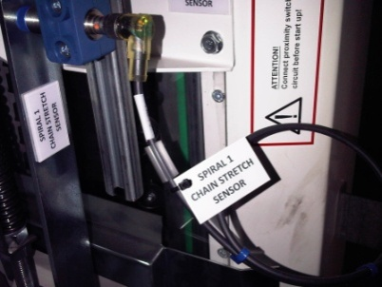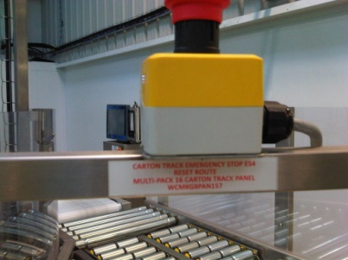

Where the field device is part of a complete network then this may be identified by colour coding the identification label.

6.7 Instrumentation
The supplier should include an option to have a Rockwell PM1000 energy meter installed with an Ethernet connection which delivers an “Output” (Pulsed or otherwise) into the PLC controller and also ideally a pulsed output from the compressed air meter that can feed into the energy meter for display over the Ethernet

6.8 Recipes / Presets
The PLC shall accumulate and display a set of current and cumulative data (Standard Data and fault recording). Current data is defined as data collection during the current day. the document, the data that is required to be recorded on the control unit is identified, but data should not be limited to this.

Recipes should be managed in sites MSSQL with only current recipes shall be stored within the PLC processor.

Optimization control will be recipe specific.

6.9 Data Handling
The PLC shall accumulate, display and transmit a set of current and cumulative data (Standard Data and fault recording). Details of data to be recorded are included within the KPI document for each specific piece of equipment.

The specific faults and data shall include (but not be limited to): machine/system runtime, machine/system downtime, mean time between faults (MTBF), mean time to repair faults (MTRF), machine /system runtime efficiency, total fault count, individual fault counts, total good output by type and total damaged by type.

6.10 Emergency Stops / Controlled stop
Emergency stop circuits to be agreed during the design phase of the project based on formal risk assessments.
- All emergency stops shall stop the entire system to which they are connected.
- All emergency stops shall be individually signalled and indicated to the OIT/Panelview.
- Emergency stop reset shall be via a button mounted on the front of the main control panel.

6.11 System or Power Failure
In the event of input supply failure the system should lock out to Emergency stop condition and/or switch over to the emergency supply Generator.

All equipment must be prevented against electrical supply spikes.

In the event of single device trip or failure the system shall continue to operate with no interference to the remainder of the system. The system shall alarm any single device trip or failure.

7. Performance

7.1 Generic Key Performance Indicators

7.1.1 Operating Environment

Operating Capability MEASURE: The plant will be expected to run initially 10 days continuously 24hrs per day. The equipment shall however be designed such that upon full line capacity requirement, production shall be continuously for 20 days out of a 21 day cycle. One additional day to be used for deep clean/machine checks. The system shall be capable of operating within the declared specification for a minimum of 3 months between planned maintenance schedules.

Operating Capability METHODOLOGY: The system will be operated, maintained and sanitised in line with manufacturer’s instructions. The system capability shall be evaluated over a rolling 12 monthly periods.

7.1.2 System Efficiency

System Efficiency MEASURE: This is the percentage of the time the system was operational, excluding external causes for downtime. The system shall have an efficiency of greater than 99.33% as a time based measure

System Efficiency METHODOLOGY: Run time is the system operating to the declared design and performance specification.

Scheduled time is when the equipment is supplied with labour and materials to specification and the outfeed is available to take away product.
System reliability = Actual available to run time / Scheduled time. This should be measured over an 8-hour period. The 99.33% average should be achieved over a rolling 3 monthly periods. The system will be operated, maintained and sanitised in line with manufacturers instructions.

The system should also log all reasons for faults, so that this data can be used as part of the validation period to understand the causes for downtime. Data should be available on the control unit showing the mean time between fault (i.e. an incidence that requires operator intervention), and the mean time to repair (i.e. from the fault occurring the average time it takes for the system to return to production mode).

7.1.3 Downtime

Downtime MEASURE: The equipment is required to function with no more than 0.1% downtime due to major failures.

Downtime METHODOLOGY: Downtime should be logged as part of the standard shift data collection and calculated as a percentage of total operational time.

The total time that the machine is in fault mode should also be available from the control unit (re-set at the same time as the running time).

The system should also log all reasons for faults, so that this data can be used as part of the validation period to understand the causes for downtime.

7.1.4 Cost of Ownership

Cost of Ownership MEASURE: The total cost of all consumable, maintenance and service items inclusive of labour for the whole system should not exceed 1.5% of the initial capital cost per annum.

Cost of Ownership METHODOLOGY: All parts, consumables and labour required to operate, sanitise and maintain the machine should be recorded during the total trial duration. The costs should be identified and pro rata for a full year duration. The site should continue to track this cost for the first 5 years of the machine’s life.

7.1.5 Metal to Metal Contact

Metal to Metal Contact MEASURE: No unintentional signs of metal - metal contact. No generation of metal swarf or slivers that within the product zone or that could be transferred to the product zone.

Metal to Metal Contact METHODOLOGY: Visual inspection of system during production shutdown.

7.1.6 Product Spillage

Product Spillage MEASURE: No repetitive product spillage.

Product Spillage METHODOLOGY: Visual inspection of equipment. System to be fully operational at maximum throughput.

7.1.7 Hold-up Points

Hold Ups MEASURE: No evidence of product hold-up points / dead spots.
No accumulation or build up of product debris.

Hold Ups METHODOLOGY: Visual inspection of equipment.

7.1.8 Waste

Please refer to specific KPI’s for machine efficiency and oil turnover.

7.2 Project Specific Key Performance Indicators

7.2.1 Thermal Transfer Efficiency
Burner and Heat Exchanger Efficiencies to meet PI documented specifications and use the PI method of calculation. See appendix 1.
Efficiency should meet the target value of 82.5 % (+ or – 1.5%) across the full delta T range of 19.0 – 25.6 ºC. Efficiency values are to be achieved using HOSO RO (as of March 2013) cooking oil for capacity ranges included in the below table with an oil flow rate of 284 m³/h.

Actual | FL |  |  |  |  | Delta T
Solids | Solids | 18 | 19 | 19.5 | 20 | 21.5 | 22 | 22.5 | 23 | 23.5 | 24 | 24.5 | 25 | 25.5 | 26
14.5 | 12 | 919 | 970 | 995 | 1021 | 1097 | 1123 | 1148 | 1174 | 1199 | 1225 | 1250 | 1276 | 1301 | 1327
15.7 | 13 | 994 | 1049 | 1076 | 1104 | 1187 | 1214 | 1242 | 1270 | 1297 | 1325 | 1352 | 1380 | 1408 | 1435
16.9 | 14 | 1069 | 1128 | 1158 | 1188 | 1277 | 1307 | 1336 | 1366 | 1396 | 1425 | 1455 | 1485 | 1514 | 1544
18.1 | 15 | 1145 | 1208 | 1240 | 1272 | 1367 | 1399 | 1431 | 1463 | 1494 | 1526 | 1558 | 1590 | 1622 | 1653
19.3 | 16 | 1221 | 1289 | 1323 | 1357 | 1458 | 1492 | 1526 | 1560 | 1594 | 1628 | 1662 | 1696 | 1730 | 1764
20.5 | 17 | 1298 | 1370 | 1406 | 1442 | 1550 | 1586 | 1622 | 1658 | 1694 | 1730 | 1766 | 1802 | 1838 | 1874
21.7 | 18 | 1375 | 1451 | 1489 | 1527 | 1642 | 1680 | 1718 | 1757 | 1795 | 1833 | 1871 | 1909 | 1948 | 1986
22.8 | 19 | 1453 | 1533 | 1574 | 1614 | 1735 | 1775 | 1816 | 1856 | 1896 | 1937 | 1977 | 2017 | 2058 | 2098
24.0 | 20 | 1531 | 1616 | 1659 | 1701 | 1829 | 1871 | 1914 | 1956 | 1999 | 2041 | 2084 | 2126 | NA | NA
25.2 | 21 | 1610 | 1700 | 1744 | 1789 | 1923 | 1968 | 2013 | 2058 | 2102 | NA | NA | NA | NA | NA

Methodology
Measurement after commissioning at site.
To be measured at max and min ends of operating range and for the full first year of operation. This will be evaluated on a 3 monthly basis and the first 3 months will influence payment terms.

7.2.2 Oil Temperature Set Point Response.
Capability to respond to a +/- 3deg change in inlet temp set point with a Root Mean Square Error equal or less than 2.0. This will apply across the range of outputs and the range of Delta T.
Methodology
Measurement after commissioning at site. Change temp set point by +3 deg and collect 25 samples at 5 sec. intervals. When steady state is reached change set point by –3 deg and collect 25 samples at 5 sec intervals.
NOTE: Moisture loop is not active during this test.
Results to meet RMSE less than or equal to 2.0 deg C.

7.2.3 System Reliability

See Section 7.1.2

7.2.4 Capacity/Operating Environment

KPI
The burner and overall system should be rated and sized to give 20% spare capacity over and above the capacity required to run a PC 36 APC+ system.
The plant will be expected to run the PC 36 APC+ throughput (2100 kg/h max. output chips per hour) 24 hrs a day .
Methodology
The system will be operated and maintained in line with manufacturers instructions. The system capability shall be evaluated over a rolling 12 monthly periods.
Theoretical maximum output capability will be calculated after commissioning based on performance of PC36 APC+ line output.

Gas – Diesel commissioning first service November.

7.2.5 Oil Turnover rates

KPI
The system should be designed so that the total oil in the system is replaced within 8.5 hours through the full range of system throughputs (1300 to 2100 Kgs/hour)
This equates to a Delta T range of 19 deg C to 25.6.
Methodology
Measurement at commissioning and for a 3- month period of full operation. Theoretical calculation of turnover rates at PC36 APC+ throughputs.

7.2.6 Burner Turn-Down Rate

KPI
The system should be designed so that when in standby mode (eg line stop with no slices fed to fryer) the oil temperature remains stable and within 2 Deg C of the temperature set-point.
Methodology
Measurement at commissioning and for a 3- month period of full operation.

7.2.7 Integrity of Insulation/Refractory

KPI
The Insulation lining should have a minimum life of 5 years before extensive repair or replacement is required.
No evidence of product hold-up points / dead spots/hot spots
No accumulation or build up of product debris.

Methodology
Visual inspection of system and surface temperature measurements at installation and commissioning.

7.2.8 Oil Film Temperatures

KPI
Temperatures at HE coil surfaces to be within limits to control oil degradation and hence minimise FFA generation. To meet PI specifications for FFA levels.
Response to URS to include oil film temperatures at the Heat Exchanger across the operating range of Delta T of 19 to 25.6 deg C.

Methodology
Check of FFA levels at commissioning using the standard Q.A. Lab methodology.

7.2.9 Surface Temperatures

KPI
Skin temperatures of burner chamber, pipework, heat exchanger and all exposed and accessible surfaces should be below the burn threshold as defined in EN ISO 13732-1:2008. Response to URS to include the expected surface temperatures, the contact period assumed and the metal coating type and thickness.
Methodology
Check of all surface temperatures at commissioning including measurement of surface temps with a suitable, calibrated instrument.

7.2.10 Destruction of Fryer Stack Contaminants

KPI
All contaminants from the fryer stack will be directed back to the burner chamber and are suitably combusted. Final stack emissions should comply with all relevant EU regulations and clean air standards.
Contaminants must not condense or build-up within the ductwork
All ducting should be self-draining
Methodology
To be measured during commissioning and confirmed after handover by use of a recognised technique and to be confirmed with supplier. This may require the use of a third party with suitable analytical and sampling equipment.
Ideally will be to an approved NAMAS standard and as a minimum include; sulphur dioxide, carbon monoxide, total nitrous oxides and oxygen.
Sampling
Method of sampling and number of samples to be agreed with supplier

Analysis
Method of analysis and report to be agreed with supplier.

7.2.11 Heat Exchanger Drainage Time and residual volume
KPI
When the Main Oil Pump stops, oil or water in the Heat Exchanger or associated pipe-work should drain back to the fryer in a reasonably short time. This time is to be advised by the supplier.
Residual oil or water remaining in the Heat Exchanger or associated pipe-work should be minimal. This quantity is to be advised by the supplier.
Methodology
The oil or water level in the fryer is measured using an ultrasonic level sensor. The drain time will be measured by the time taken for this sensor to reach maximum.
Water remaining in the Heat Exchanger or associated pipe-work will affect the De-watering time required when the fryer is filled with oil and first heated. The time to de-water the oil will be measured.

7.2.12 Noise Levels
K.P.I. (See also Section 8.5 Noise Control)
All production and ancillary equipment shall be designed, constructed and installed to ensure that noise emissions from the operation of the equipment under normal production operating conditions (ie. with and without product) both singularly and taking account of the cumulative effect of noise from adjacent equipment, shall not cause or contribute to any Personnel to be exposed to noise in excess of the Lower Action Level (L_{Ep,}d < 80dB(A)) as defined in the Physical Agents (Noise) Directive 2003/10/EC.

The supplier shall provide information and/or calculations to demonstrate that equipment in his supply complies with this requirement.

7.2.13 Corrosion
K.P.I.
It is expected that over the first 10 years of service life there will be no corrosion of key components of the system which affects the performance of the unit. There is no marinating Speedwash tanks on this process line.

7.3 Guarantees
Refer to the PepsiCo Management of Works 2012

7.4 Environment
The system will be expected to run continuously for 20 days out of a 21-day cycle.
One day to be used for deep clean / machine checks.

The system shall be capable of operating within the declared specification for a minimum of 3 months between planned maintenance schedules.

The machine will be operated, maintained and sanitised in line with manufacturers’ instructions. This is the part of the training and is delivered within the operator’s manuals. The machine capability shall be evaluated over a rolling 12 monthly period.

8. Site Impact

8.1 Buildings / Access to site
The installation area sits within a food manufacturing plant, working 24 hours a day, including weekends.

Site access will be allowed within the normal operating conditions for that site, ensuring that all contractor’s work comply with PepsiCo Health and Safety policies, food safety regulations and must be free of potential contamination.

8.2 Utilities
The Vendor is to declare all utilities requirements as part of the documentation
The supplier is to clearly indicate in writing in their tender proposal the energy consumption of the new equipment, including:
- Electricity consumption in kW/hr.
- Chilled water consumption in litres/hr
- Compressed air consumption in m³/hr.
- Any other energy consumption

8.4 Plant Environment
The equipment is to be located in a wet process area.
Is required to operate in a wide variety of conditions including: temperature from 8 to 35 degrees Celsius, relative humidity from 10 to 90 percent.

8.5 Noise Control
All production and ancillary equipment shall be designed, constructed and installed to ensure that noise emissions from the operation of the equipment under normal production operating conditions ( ie. with and without product ) both singularly and taking account of the cumulative effect of noise from adjacent equipment, shall not cause any Production Personnel to be exposed to noise in excess of the first action level (LEAV.d<80dB(A)) of the Control of Noise at Work Regulations 2005. The Contractor shall provide information and / or calculations to demonstrate that equipment in his supply complies with this requirement.

Noise measurements made by the Contractor shall conform to BS4196, Part 6, 1981, in so far as a rectangular parallel piped surface is used for the measurement surface.

For machines operating in proximity with other machines and within a reverberant environment ( ie. within a hygienic factory ) consideration shall be given to the effect of reflected noise, and the cumulative effect of noise from other nearby machines

9. Acceptances and Handover

9.1 Acceptance Testing
The vendor will agree at the design stage with the dates for a Pre Delivery Inspection (PDI).

The supplier must maintain a detailed “commissioning log” and agree the Change Management process to be used during on-site working with the site team.

Appendix 1 – Efficiency calculation & reporting

Heat exchanger efficiency trending
There will be a Heat Exchanger screen on the line SCADA system which shows the detail of the Burner and heat Exchanger with important temperatures, flows and pressures.
The efficiency that the heat exchanger is running at is to be shown on the heat exchanger screen. The calculation for this value is explained further in this section.
When the Heater efficiency button is pressed on the touch screen it will display a one hour trend as follows.

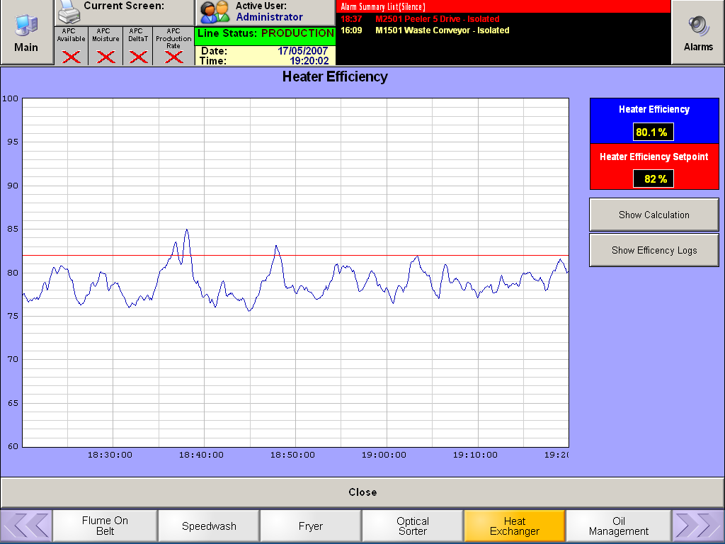

The ‘Show Calculation’ push button will show the following 2 screens that show how the efficiency is calculated and also switch to the actual values.

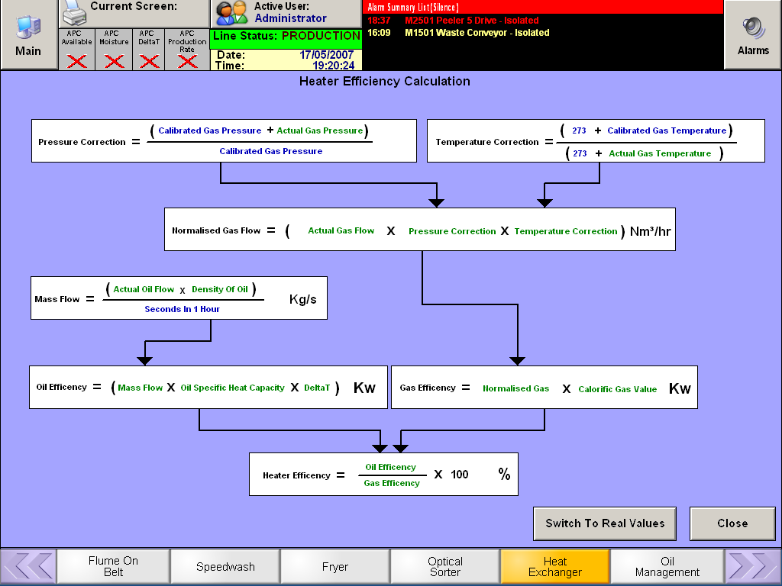

Note that for the Pressure Correction calculation, the top line should be (Local Average Atmospheric Pressure + Actual Gas Pressure).

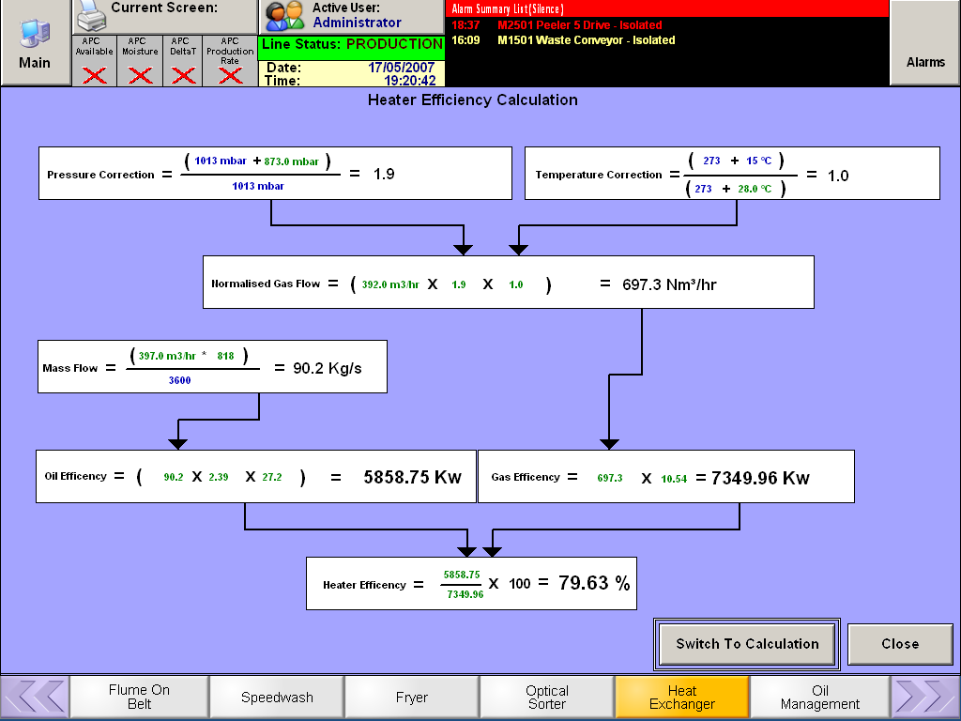
The following entries need to be added to the Process Recipe :-
1. Oil Type (HOSO RO (as of March 2013) cooking oil)
The following entries need to be added to the engineering parameters to enable the efficiency calculation :-
  - For each Oil Type - Density of Cooking oil at 150 degrees Celsius (kg/m³)
  - For each Oil Type - Specific heat of oil at 162 degrees Celsius (kJ/kgK)
  - Gross Calorific value of gas (kWh/Nm³)
  - Calibrated Gas Temperature for the Gas Temperature Correction calculation
  - Local Average Atmospheric Pressure for the Gas Pressure Correction calculation

Efficiency Logging
The efficiency is to be logged in the following way :-
The efficiency values are recorded when the system has met the following parameters for 5 minutes continuously. Then a 5 minute average data point is recorded.
- Fryer Delta T must be within the range of (Recipe Delta T Low Limit –1) to (Recipe Delta T High Limit +1) Degrees Celsius.
- Fryer Delta T must be within 0.75 Degrees Celsius of set point
- Fryer running in APC control
- Oil flow in range of 274 – 284 m3/hr
- Fryer inlet temperature must be within 0.75 Degrees Celsius of set point

Values are taken in 5sec intervals for this 5-minute average calculation.
Once 12 X 5 minute average data values are taken a 1hour average value is calculated and recorded.
Once 24 X 1 hour average values are taken a 24 hour data point is recorded
Once 28 X 24 hour average values are taken a 28 day data point is recorded
Once 11 X 28day average values are taken a Yearly data point is recorded

The efficiency is displayed in the following way. Note the 28 day and yearly data screens are not shown in this document.

